Customer Churn Analysis

# Process:

1. Read all the CSV files and took Customer Demography as master.
2. Removed row number from all other data frames except customer portfolio.
3. Joined Customer demography with customer investment and produced new data frame.
4. Joined the new data frame with Customer attribute and created new data frame.
5. Joined resultant DF with customer portfolio and got the resultant DF
6. Arranged the DF according to order asked for.
7. Analysed the data foe duplicate data/ missing data.
8. Removing null from credit score with Forward fill method.
9. Removing null from balance column with mean value .
10. Saved cleansed data.
11. Created a new DF for only exited customers.
12. Displayed age wise count of exited customers count.
13. Plot 1: Geography Wise Exist stance 🡪sn.countplot(x="Geography",data=dfCust5, hue="Exited")

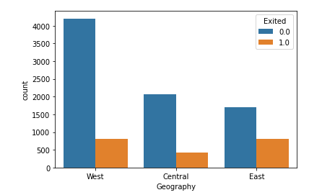

1. Plot 2: No of product wise existence🡪sn.countplot(x="NumOfProducts",data=dfCust5, hue="Exited")

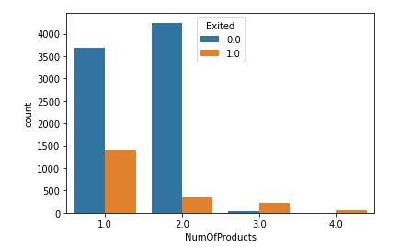

1. Plot 3:Gender wise existence🡪sn.countplot(x="Gender",data=dfCust5, hue="Exited")

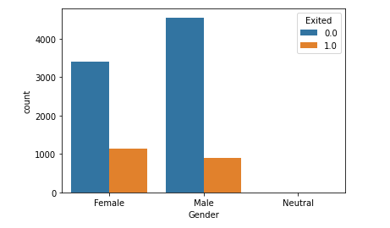

1. Plot 4 : Active member 🡪sn.countplot(x="IsActiveMember",data=dfCust5, hue="Exited")

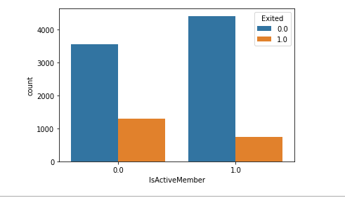

1. Plot 5: Age Wise Churn🡪sn.countplot(x="Age",data=dfCustExited, hue="Exited")

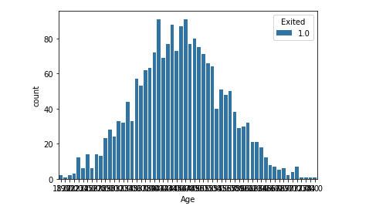

1. Plot 6: Age and Geography wise Existence🡪sn.barplot(x="Geography", y="Age",data=dfCust4, hue="Exited")

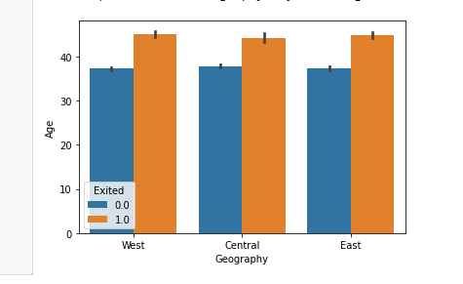

1. Plot 7: Tenure and No of Product wise Existence🡪sn.barplot(x="Tenure", y="NumOfProducts",data=dfCust4, hue="Exited")